**Lesson 4 Explanation I**

**Sequential and Factorial Explanation**

**Lesson objectives:**

* Get to know major types of Explanation
* Analyze the sample texts of the Sequential and Factorial Explanations
* Learn expressions of Explanation

1. **Explanation and its major types**

Explanations are concerned with explaining how processes happen. They imply sequences of causes and effects: Process x Process y Process z …

Stages: Phenomenon + Explanation

The typical structure of explanations is to start by specifying the Phenomenon to be explained, followed by the implication sequence that explains it, the Explanation stage.

Explanation genres are of four general types:

1. A sequential explanation consists of a simple sequence of causes and effects.
2. A factorial explanation involves multiple causes.
3. A consequential explanation involves multiple effects.
4. A conditional explanation: effects may vary depending on variable conditions.

In written explanations, causal relations need not be made explicit. That is, the causality may not be explicitly realized as causal conjunctions like “because, so, therefore”, but can be implicit in the explanation genre. The genre is typically announced in the Phenomenon stage, so the reader can infer causal relations where they are not stated.

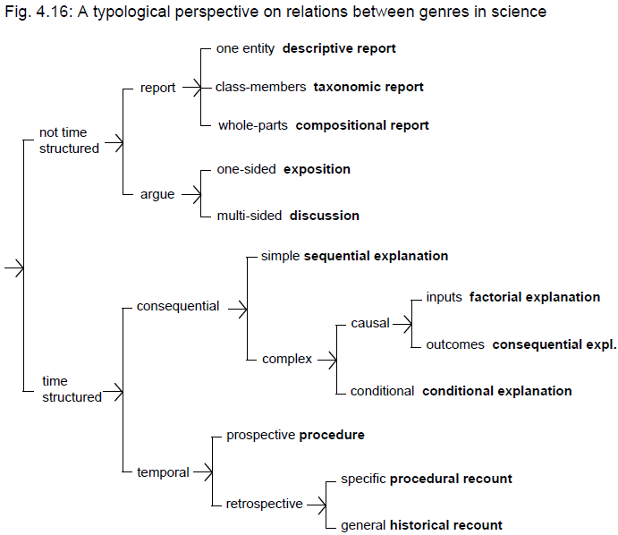（*Genre Relations*, p. 157）

**II． Sequential explanations**

Sequential explanations are typically constructed as a series of events, in which an obligatory causal relation is implied between each event.

**Sample text 1: A lowland freshwater wetland – Lower Mary River**

*Many of the wetlands of the north have been formed by the large rivers that flow from the rugged escarpments that fringe the Top End coastline.* *In the wet season huge volumes of water flow from the escarpments.* *When this water hits the flood plains* *it slows down* *and spreads out* *forming the wetlands.* *The wetlands border the sea,* *however a series of sand ridges stopped sea water flowing into the wetlands.* *This kept the wetland water fresh.*

**Analysis:**

|  |  |
| --- | --- |
| **Phenomenon** | *Many of the wetlands of the north have been formed by the large rivers that flow from the rugged escarpments that fringe the Top End coastline.* |
| **Explanation** |  |
| formation | *In the wet season huge volumes of water flow from the escarpments.*  *When this water hits the flood plains*  *it slows down*  *and spreads out*  *forming the wetlands.* |
| freshwater | *The wetlands border the sea,*  *however a series of sand ridges stopped sea water flowing into the wetlands.*  *This kept the wetland water fresh.* |
| **[Definition** | Wetlands formed in this way are known as lowland freshwater wetlands.**]** |

**Sample text 2: Fire – a natural process which is now significantly influenced by humans**

*Since the advent of the present vegetation pattern around 10,000 years ago, fire has been crucial in modifying the Mallee environment. Regeneration of the Mallee depends on periodic fires. Old mallee produces a build-up of very dry litter and the branches themselves are often festooned with streamers of bark inviting a flame up to the canopy of leaves loaded with volatile eucalyptus oil. A dry electrical storm in summer is all that is needed to start a blaze, which, with a very hot northerly wind behind it will race unchecked through the bush. The next rain will bring an explosion of ground flora; the summer grasses and forbs not able to compete under a mallee canopy, will break out in a riot of colour. New shoots of mallee will spring from the lignotuber and another cycle of succession will begin.*

*The dead branches become hollows for Major Mitchell cockatoos and other birds on whose eggs the goanna feeds. The more open bush provides green ‘pick’ for kangaroos and emus. The low shrubs give a home for zebra finches, but the abundant litter need by the mallee fowl to build a nest is no longer available.*

*Traditionally, Aborigines would periodically have lit small areas to flush out game and provide some fresh grass for later in spring. The result of this over generations would have been a patchwork of small moderate burns.*

*The European settlers, however, brought with them a very different attitude to fire. Fire was seen as danger to crops and livestock and should be extinguished if possible. The result of this is that litter builds up until it all goes up in one fierce blaze, usually in the middle of summer when conditions are very hot.*

**Analysis:**

|  |  |
| --- | --- |
| **Explanation:** | **succession cycle** |
| fuel |  |
| ignition |  |
| regeneration |  |
| reoccupation |  |
| **Extension:** | **human influences** |
| Aborigines |  |
| European |  |

**III. Factorial explanations**

In scientific factorial explanations, events may be explained by two or more contributing factors.

**Sample text 3 The mulga tree**

*How can plant life grow so well in such dry, hot and infertile places? The mulga tree likes long droughts – if it is too wet mulga trees will not grow.*

*The shape of the mulga tree is the key to it surviving dry times. The branches of the mulga fan out from the bottom – like a huge half moon. The branching leaves and stem catch the rain and it trickles down to the soil. This traps more rainfall than if the tree grew straight up. The mulga catches more water than a gum tree. The water is stored in the soil to be used by the tree during the next drought.*

*Even the mulga’s leaves help it to survive the drought. They are a silvery grey colour. The sun’s rays bounce off the leaves helping the plant to stay cool.*

*Also the mulga tree makes its own food by dropping thousands of leaves.*

**IV. Exercises**

**Exercise 1:** Answer questions about the following text.

1. What is the “Phenomenon”? What part belongs to the stage of Explanation?
2. Please refer to sample text 1 and analyze the implication sequence of the cause/effect explanation.

*What causes and transmits sounds? Figure 15 shows a vibrating object producing sound waves. As the object moves to the right it pushes or compresses the air particles next to it. The compressed air particles then push on the particles to their right and compress them. As each air particle pushes on the next one to its right the compression travels through the air. When the vibrating object moves back to its left the air particles next to it are no longer being pushed. They spread out or are stretched apart. As a compression travels through the air it is followed by the stretching apart of air particles. Because the vibrating object continually moves back and forth a series of compressions and stretches of air particles is sent out from the object.* (*Genre Relations,* p. 146)

**Exercise 2:** In the following explanation, lightening is explained in temporally unfolding terms. This explanation goes through four distinct phases.

|  |  |
| --- | --- |
|  | ***Explanation of lightning*** |
| **explanation**  **sequence** | *Warm air rise in hot clouds and encounters cold air, charging the particles in the cloud making them both positive and negative charges and this is called static electricity. When enough positive and negative charges occur, they build up too much energy and explode in a flash of light that we call lightning. This flash of light helps balance out the number of negative and positive charges in atmosphere.* |
| **two types of lightning** | *Sometimes the flash of light is movement within the cloud and sometimes it is lightning movement between the atmosphere and the ground. The movement between the atmosphere and the ground is the reason that tall objects on earth like trees are struck by lightning.* |
| **thunder & lightning** | *Light travels faster than sound, and because of this, we see the flash lightning of lightning before we hear the clap of thunder. There is thus a direct relationship between thunder and lightning; they are not separate phenomena.* |
| **duration** | *Thunder and lightning lasts only as long as is necessary to get all the electrical charges in the atmosphere back in balance.* |

1. In the initial explanation sequence, most of the temporal links are left implicit; we have to understand from expectations about the genre that one event is following another. Please add temporal linking words to make implicit temporal relations to be more explicit in parenthesis.

*Warm air rise in hot clouds and (then) encounters cold air, (then) charging the particles in the cloud ( ) making them both positive and negative charges and this is called static electricity. When enough positive and negative charges occur, ( ) they build up too much energy and ( ) explode in a flash of light that we call lightening. ( ) This flash of light helps balance out the number of negative and positive charges in atmosphere.*

1. Please recognize the cause/effect sequence in the phases of “two types of lightning” and “thunder & lightning”.

**Exercise 3:** Read the following text and answer the questions. 1) What type of explanation does the text use? 2) In what way does the text imply **causality?**

**Heart explanation**

*The left pump sends the blood to the arteries and then to the head to the toes. The blood carries oxygen that slowly gives up while going through the body. Then the blood goes back to the lungs to get more oxygen.*

**Exercise 4:** How does yeast raise bread and pastry? Rearrange the sentences below in the correct order to create an explanation.

1. That’s how yeast raises bread and pastry.
2. The process of leavening bread is an organic process. Starch cells in flour get eaten by yeast.
3. Sugars are metabolized to produce alcohol and carbon dioxide. Carbon dioxide is a gas and forms the bubbles in particular pastry.
4. Yeast is a raising agent. It’s a living bacteria.
5. The gluten structure in the flour traps the carbon dioxide and as the yeast keeps feeding the bread keeps rising.

**Exercise 5:** Group discussion. Please use a sequential or factorial explanation in your discussion.

1. What have influenced the quality of your sleep?
2. What are the causes of increased obesity in China?
3. Why would more and more Chinese like to travel around the world?
4. What possibly cause Chinese couples in big cities to decide to have no or fewer children?

**Exercise 6:** Use *–ing* clauses to indicate cause and effect.

*(thus)* + *-ing* clause of result = *therefore, as a result*

e.g. The magma flows into the pores of the rocks; as a result, the rocks rupture.

The magma flows into the pores of the rocks, (*thus) causing* them to rupture.

e.g. A current is sent through the material. As a result, the electrons are polarized.

A current is sent through the material, *(thus) polarizing* the electrons.

Combine the ideas presented in each of the statements by using an –ing clause of result. Work with a partner.

1. Technical improvements in resource efficiency can lower demand for resources. This results in low prices.
2. The plants extract nickels and zinc; hence, the soil is left uncontaminated.
3. Rainfall levels plummeted. A slow, but steady, loss of grasses occurred. As a result, the region was transformed into a desert.

**Homework assignment:** Write a factorial explanation on the topic of “**Causes of Students’ Sleep Deprivation (睡眠不足)**” about 150-200 words. Label the two major stages: Phenomenon and Explanation, and underline the factors. **It is due in Week 6.**

**Language focus: Explanation expressions**

|  |  |  |  |
| --- | --- | --- | --- |
| A contributes to B (A causes B) | in the cause of… | owing to | accordingly |
| attribute A to B (B causes A) | the cause for… | due to | therefore |
| this is the reason why… | reason for | give rise to | hence |
| with reason that… | by reason of… | generate | thus |
| for the reason that… | owe A to B (B is the reason for A) | ascribe A to B (B causes A) | consequently |
| why…is because/that… |  |  |  |

**Verbs expressing causality**

|  |  |  |
| --- | --- | --- |
| Lack of protein | *may cause can lead to can result in* | mental retardation. |

|  |  |  |
| --- | --- | --- |
| Low levels of chlorine in the body | *can give rise to* | high blood pressure. |

|  |  |  |
| --- | --- | --- |
| Much of the instability | *stems from* | the economic effects of the war. |

|  |  |  |
| --- | --- | --- |
| Kwashiorkor is a disease Beri-beri is a disease Scurvy is a disease | *caused by resulting from stemming from* | insufficient protein. vitamin deficiency. lack of vitamin C. |

**Nouns expressing causality**

|  |
| --- |
| The most *likely causes*of X are poor diet and lack of exercise. |

|  |
| --- |
| A *consequence* of vitamin A deficiency is blindness. |

|  |
| --- |
| Physical activity is an important *factor* in maintaining fitness. |

|  |
| --- |
| Many other medications have an *influence* on cholesterol levels. |

|  |
| --- |
| Another reason *why* Xs are considered to be important is that ……. |

**Prepositional phrases expressing causality**

|  |  |  |
| --- | --- | --- |
| 200,000 people per year become deaf | *owing to because of as a result of* | a lack of iodine. |

**Sentence connectors expressing causality**

|  |  |  |
| --- | --- | --- |
| If undernourished and retarded children do survive to become adults, they have decreased learning ability. | *Therefore, Consequently, Because of this, As a result (of this),* | when they grow up, it will probably be difficult for them to find work. |

**Adverbial phrases expressing causality**

|  |  |  |
| --- | --- | --- |
| Malnutrition leads to illness and a reduced ability to work in adulthood, | *thus/thereby* | perpetuating the poverty cycle. |

|  |  |  |
| --- | --- | --- |
| The warm air rises above the surface of the sea, | *thus/thereby* | creating an area of low pressure. |

**Other examples**

As a consequence of X, it appears that winds alone are not the causative factor of…….  
Due to X and Y inflowing surface water becomes more dense as it …….  
X and Y are important driving factors of Z.  
The mixing of X and Y exerts a powerful effect upon Z through ……

**Possible cause and effect relationships**

This suggests a weak link may exist between X and Y.  
Stomach cancer in many cases *may be associated with* certain bacterial infections.  
A high consumption of seafood *could be associated with* infertility.  
There is some evidence that X *may affect* Y.

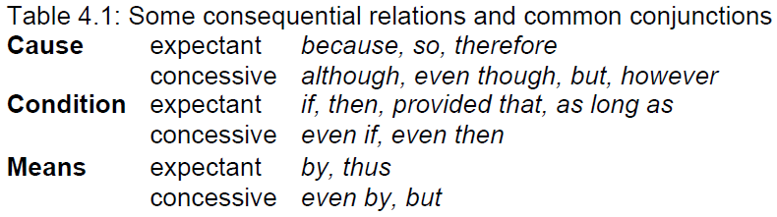

References:

(*Learning to Read,* p. 87)